**USER MANUAL**

**Project**

**Project**

**Navigation**

To access Projects, go to:

Home > Projects > Projects > Project

**Screenshot**

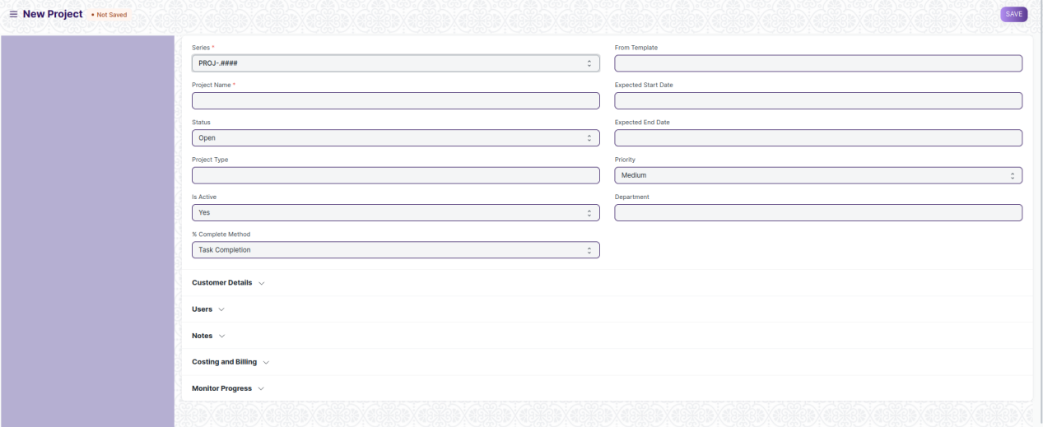

**How to Create a Project**

1. Go to the Project list and click on New.
2. Add the following details:

* **Project Name:** Title of the Project.
* **Status:** The default status of a Project is going to be 'Open' which can later be changed to 'Completed' or 'Cancelled'.
* **Expected End Date:** Enter the date on which you aim to finish the project.

1. Save.

**Task**

**Navigation**

To access Tasks, go to:

Home > Projects > Projects > Task

**Screenshot**

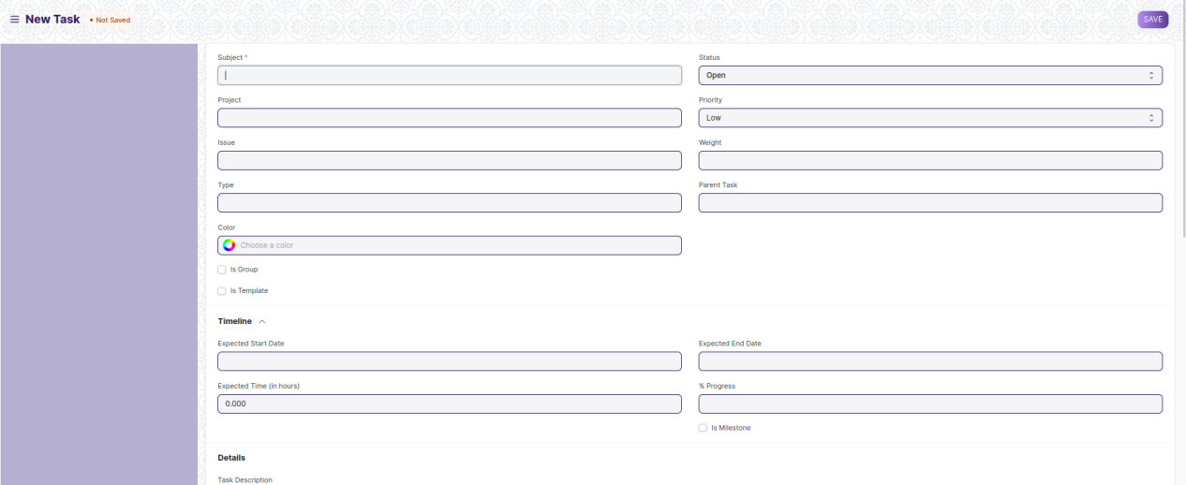

**How to Create a Task**

1. Go to the Task List and click on New.
2. Add the subject of the task.
3. Save.

Alternatively, a task can also be created from a Project in the following way:

1. Go to the Project for which you want to create a new task.
2. Go to Task under the Project section on the Dashboard. The plus icon '+' here would direct you to the task creation page.
3. Add the subject of the task.
4. Save.

**Project Template**

**Navigation**

To access Project Template, go to:

Home > Projects > Projects > Project Template

**Screenshot**

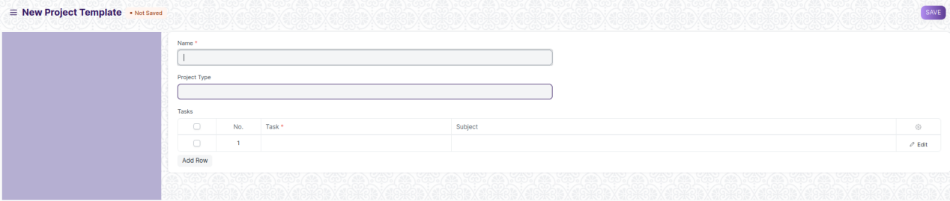

**How to Create A New Project Template:**

1. Go to the Project Template List and click on New.
2. Add the following details:

* **Project Template Name:** Title of the Project Template
* **Project Type:** Project Templates, just like projects can be classified into different project types, e.g., Internal or External.
* **Tasks:** Each Project Template will have a set of a predefined sequence of tasks. In this table, you can select the tasks you want for this template.

**Project Type**

**Navigation**

To access Project Type, go to:

Home > Projects > Projects > Project Type

**Screenshot**

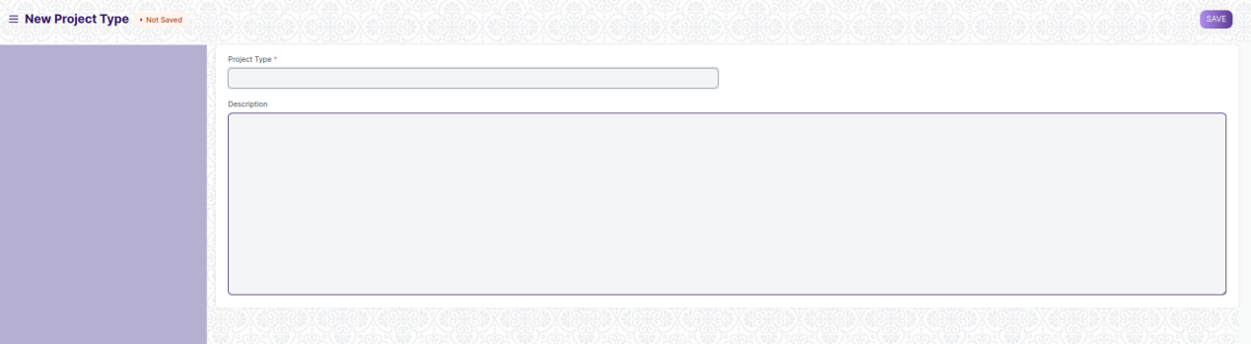

**How to Create a Project Type**

1. Go to the Project Type List and click on New.
2. Add the name of the Project Type and description
3. Save.

**Project Update**

**Navigation**

To access Project Update, go to:

Home > Projects > Projects > Project Update

**Screenshot**

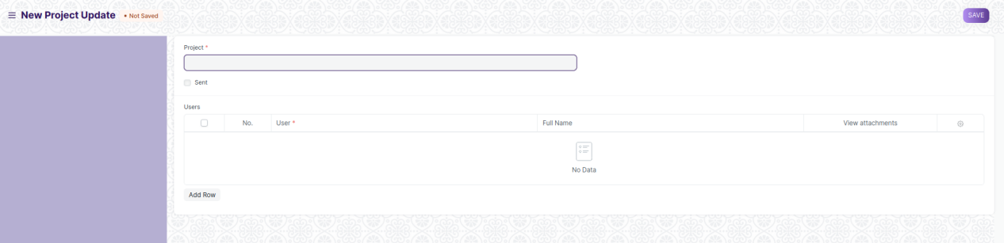

**How to Create a Project Update**

1. Go to the Project Update List and click on New.
2. Add the name of the Project for which you want to send an update.
3. Add the name of the Users to whom you want to send the Project Update in the Child Table. These Users could be your Customers or any other Internal or External Stake Holders.
4. Save and Submit.

Once you have submitted the Project Update, an email is sent to the selected stakeholders with project updates

**Timesheet**

**Navigation**

To access Timesheet, go to:

Home > Projects > Time Tracking > Timesheet

**Screenshot**

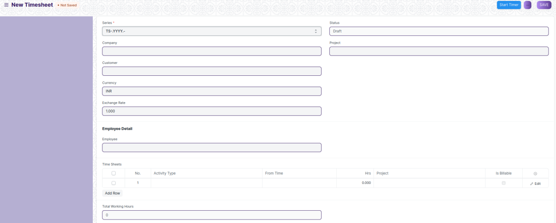

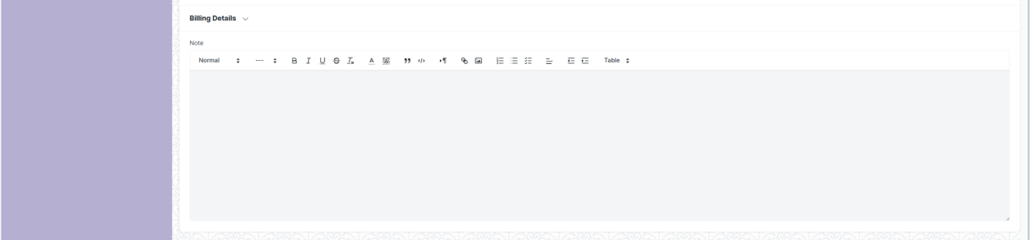

**How to create a Timesheet**

1. Go to Timesheet list and Click on New.
2. Enter the Company name and the Employee Code.
3. Add the following details to the field 'Time Sheets'.

* **Activity Type:** Add the type of activity for which the Time Sheet has been created.
* **From Time:** Enter the date and time at which the work was started.
* **Hrs:** Enter the number of hours for which this Time Sheet has been created. One Timesheet can be used to track the work hours on multiple days as well.
* **Project:** If this Time Sheet needs to be tagged to a particular Project, you can add the name of the Project here.
* **Bill:** This box needs to be checked if this particular Time Sheet is a billable.

1. Click on 'Add Row' to add more such Time Sheets.
2. Save.
3. After saving the Timesheet, according to the details entered in the different Time Sheets, the Start Date, End Date and the Total Working Hours will get updated automatically. Click Submit.

Alternatively, a Timesheet can also be created from a Task in the following way:

1. Go to the Task for which you want to create a new Timesheet.
2. Go to 'Timesheet' under the Activity section on the Dashboard. The plus icon '+' here would re-direct you to the Timesheet creation page.
3. Follow the steps to create a Time Sheet.

**Activity Type**

**Navigation**

To access Activity Type, go to:

Home > Projects > Time Tracking > Activity Type

**Screenshot**

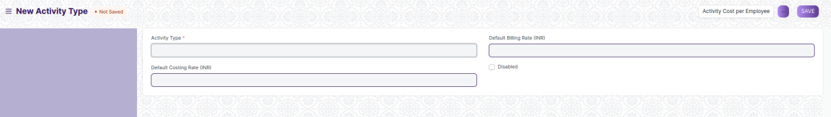

**How to create Activity Type**

1. Go to the Activity Type List and click on New.
2. Add the subject of the Activity Type.
3. Save.

Additionally, you can also add the Default Costing Rate and Default Billing Rate for each Activity.

Further, The Default Costing Rate and the Default Billing Rate for Individual Employees can also be configured. This can also be configured using Activity Cost

**Activity Cost**

**Navigation**

To access Activity Cost, go to:

Home > Projects > Time Tracking > Activity Cost

**Screenshot**

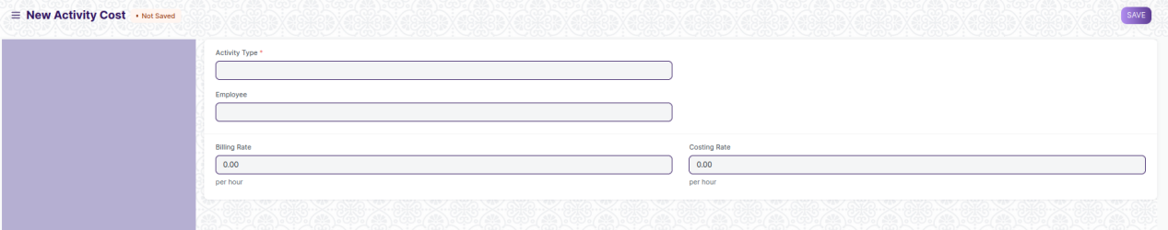

**How to create Activity Cost**

1. Go to the Activity Cost list and click on New.
2. Add the name of the Employee for whom you are configuring the Activity Cost.
3. Add the Costing Rate and the Billing Rate for the Employee.
4. Save.

Alternatively, an Activity Cost can also be created via the Activity List.